

Embedded Hardware Design

**2012**

**Presented By:**

**Swena Gupta (201001104)**

**Vipul Garg (201001049)**

Blind Vision

***Guided by: Prof. Prabhat Ranjan***

Concept:

The device works on the principle of converting distance of obstacle from the user to sound so that the user can identify the distance with the help of change in frequency of sound. This is helpful to blind people as they are capable of analysing sound signals better than people who can see but the only problem is that the obstacles like walls, doors etc. does not make sound, and our device help them to listen those silent objects and provide them better sense of their surroundings.

Details:

For sensing distance we have used ‘Sharp 2Y0A21’ distance sensor with a range of 10cm – 80 cm, the output( voltage value) is first converted to digital value through the inbuilt ADC of ATmega32, the digital voltage value is then converted into distance using the formula ‘6050/adc_value’ which is obtained from the datasheet of the sensor.

The distance range is divided in 14 equal levels which will give different output sound frequency. For generating sound, the headphone speaker is turned on and off rapidly using square wave and this on-off period is changed to change the frequency of sound. No sound is played when the obstacle is out of the range of distance sensor, as the distance decreases the frequency of sound increases which is easily identifiable by the user.

Circuit Diagram:

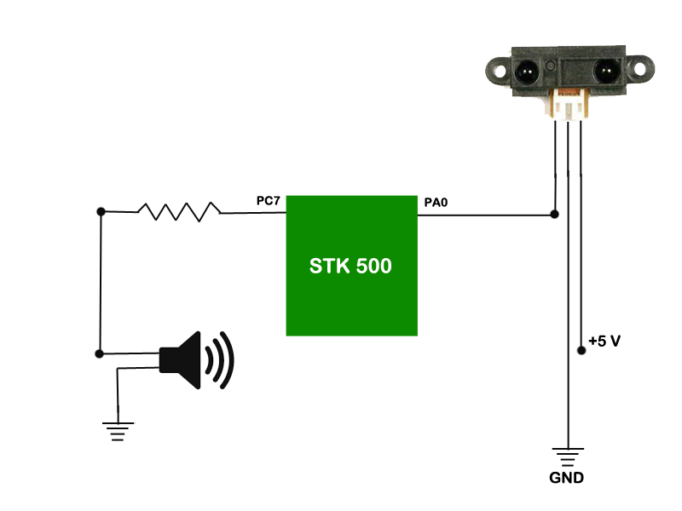

**Special Thanks**

Prof. Rahul Dubey for providing the distance sensor.

TAs

Lab Assistant

Ramesh Prajapati Sir

for helping us throughout the project

***